Coursework Cover Sheet
Students should complete the input fields contained in this form and attach it in front of your formal assessment submission. All fields within this form are required. Please ensure that check boxes and radio buttons are appropriately selected. The last three questions are just for you to personally consider.
Assessment information:
Student name: | Youssef Hegazi Elseisi
Module name: | User Experience
Assessment title: | Low-fi User Interaction Flow for App
Academic Misconduct / Plagiarism Declaration:
By attaching this front cover sheet to my assessment I confirm and declare that I am the sole author of this work, except where otherwise acknowledged by appropriate referencing and citation, and that I have taken all reasonable skill and care to ensure that no other person has been able, or allowed, to copy this work in either paper or electronic form, and that prior to submission I have read, understood and followed the University regulations as outlined in the:
Academic Integrity Policy and Procedure for Academic Misconduct
Have you checked the following? This will help your assessment achievement.
I have applied the learning outcomes for this module. | ☒
I have checked for Academic Integrity via Turn-it-in. | ☒
I have followed the guidance in the Assessment Brief and have not used AI to boost my grade unfairly. | ☒
I have used references in accordance with instructions in the Assessment Brief. | ☒
I have proofread my work for spelling, grammar, and punctuation. | ☒
I have checked that the word count/size of this submissions accords with the guidance provided in the brief. | ☒
Well-being:
We wish to support any student who is experiencing mitigating circumstances which prevents students from performing to the best of their ability when completing assignments. If you are experiencing such circumstances, then you may apply for Mitigating Circumstances. Wherever possible this must be done prior to handing in your assignment.
Do you need to apply for mitigating circumstances for this assignment? No
Please refer to the Mitigating Circumstances Policy
Questions you may wish to consider before submitting your work:
1. Have I allowed sufficient time to prepare this assessment?
2. Have I reflected on previous feedback and made improvements in accordance with advice?
3. What grade am I expecting?

How to Use the App
1. Frame 1: Home Screen
- Browse Vendors: Users can sort vendors by collection time, distance, and rating to enhance decision-making (Tullis and Albert, 2013; Nielsen, 2020).
- Navigation: Tapping a vendor's logo directs users to the respective menu, facilitating intuitive navigation (Usability.gov, n.d.-a).
2. Frames 2-3: Menu Categories
- Categorization: Menus are divided into Nibbles, Bytes, Mega-Bytes, and Giga-Bytes, aiding users in locating items within their budget (Snyder, 2003).
- Selection: Users select a category to view items and add them to their order, streamlining the selection process (Shneiderman et al., 2017).
3. Frame 4: Basket Screen
- Options: Users can add more items or proceed to checkout, providing control over the ordering process (Shneiderman et al., 2017).
4. Frame 5: Order Summary Screen
- Review: Displays order details, total price, and estimated delivery time, allowing users to confirm accuracy before finalizing (Krug, 2014).
- Actions: Options to cancel or place the order offer flexibility (Norman, 2013).
5. Frame 6: Order Confirmation Screen
- Details: Presents order summary, delivery information, and payment details, confirming the transaction (Hassenzahl, 2003).
- Tracking: Includes an option to track the order status (Law et al., 2009; UX Planet, 2021).
6. Frame 7: Order Status Screen
- Updates: Provides real-time updates on order preparation and collection, keeping users informed (Tullis and Albert, 2013).
7. Frame 8: Map Screen
- Navigation: Displays the vendor’s location and assists users in navigating back to the menu, enhancing spatial awareness (Shneiderman et al., 2017; Nielsen, 2020).
8. Frame 9: Order History Screen
- Access: Allows users to view past orders, including items, prices, and dates, facilitating reordering (Krug, 2014).
9. Frame 10: Rating & Reviews Screen
- Feedback: Enables users to submit or view ratings and reviews, fostering community engagement (Hassenzahl, 2010; UX Collective, 2023).
10. Frames 11-12: Account and Payment Screens
- Account Management: Users can view and edit personal information, ensuring data accuracy (Law et al., 2009).
- Payment Methods: Facilitates management or addition of payment methods, streamlining the checkout process (Usability.gov, n.d.-a).
Navigation
- Persistent Menu: A bottom navigation bar with Home, Orders, and Account buttons provides easy access to main sections, aiding user orientation (Norman, 2013).

Target Audience Personas
Uclan Staff Persona Uclan Student Persona
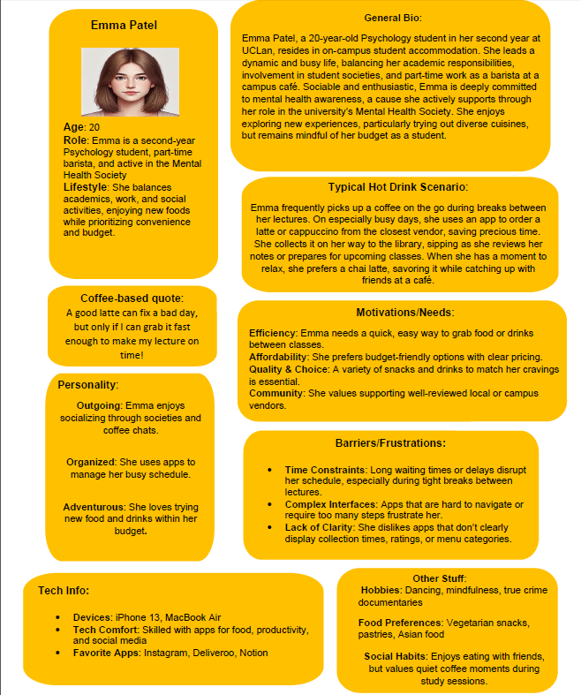
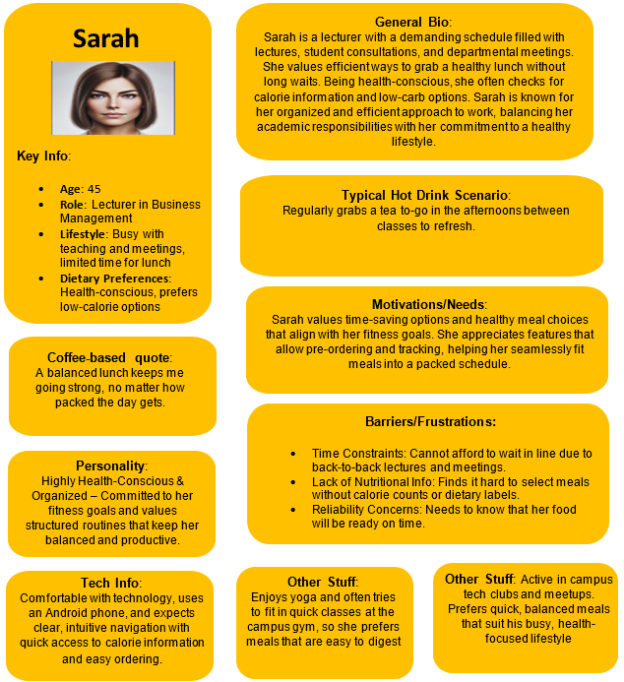

User interface (UI) flow diagram:
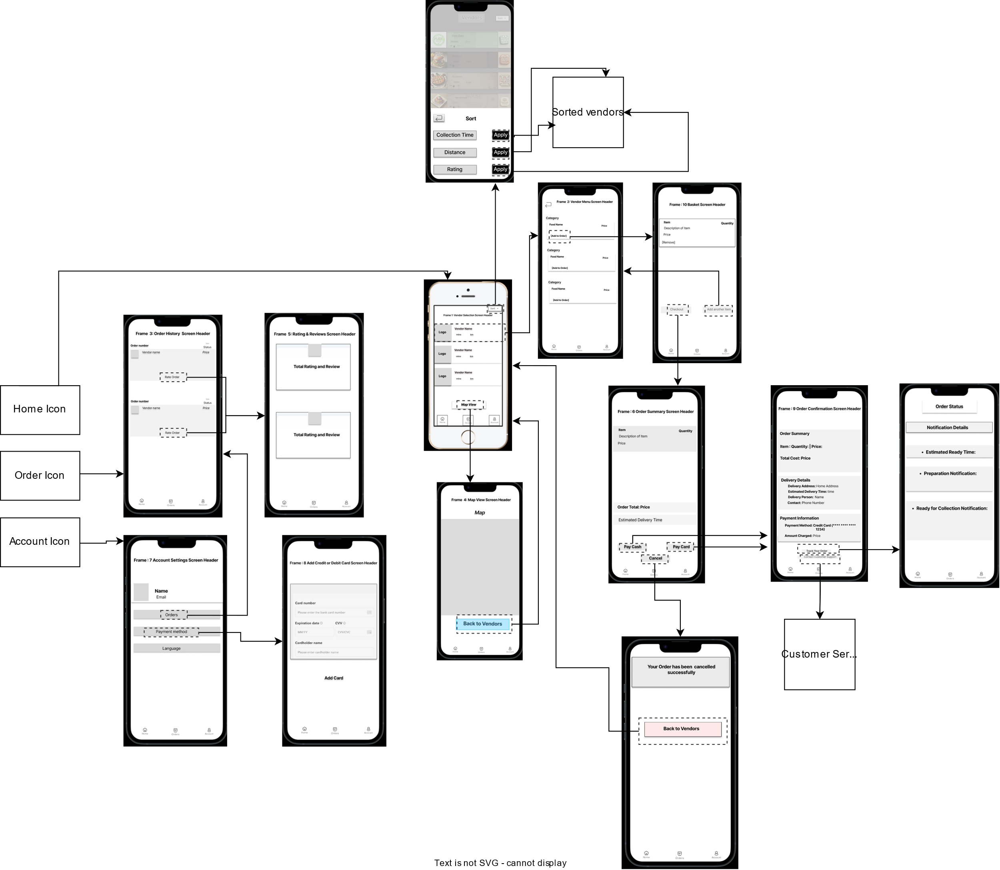
Flowchart:
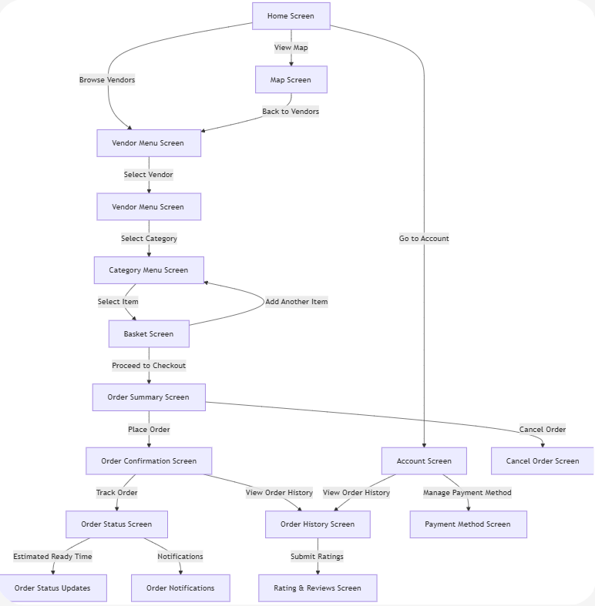

References:
Hassenzahl, M. (2003) 'The thing and I: understanding the relationship between user and product', Funology, 31, pp. 31-42.
Hassenzahl, M. (2010) Experience design: technology for all the right reasons. San Rafael, CA: Morgan & Claypool.
Krug, S. (2014) Don't make me think, revisited: a common sense approach to web usability. 3rd edn. Berkeley, CA: New Riders.
Law, E. L.-C., Roto, V., Hassenzahl, M., Vermeeren, A. P. and Kort, J. (2009) 'Understanding, scoping and defining user experience: a survey approach', Proceedings of the SIGCHI Conference on Human Factors in Computing Systems, pp. 719-728.
Nielsen, J. (2020) '10 usability heuristics for user interface design', Nielsen Norman Group, 1 April. Available at: https://www.nngroup.com/articles/ten-usability-heuristics/ (Accessed: 13 December 2024).
Norman, D. A. (2013) The design of everyday things. Revised and expanded edition. New York: Basic Books.
Shneiderman, B., Plaisant, C., Cohen, M., Jacobs, S., Elmqvist, N. and Diakopoulos, N. (2017) Designing the user interface: strategies for effective human-computer interaction. 6th edn. Boston: Pearson.
Snyder, C. (2003) Paper prototyping: the fast and easy way to design and refine user interfaces. San Francisco: Morgan Kaufmann.
Tullis, T. and Albert, B. (2013) Measuring the user experience: collecting, analyzing, and presenting usability metrics. 2nd edn. Waltham, MA: Morgan Kaufmann.
Usability.gov (n.d.-a) 'User interface design basics'. Available at: https://www.usability.gov/what-and-why/user-interface-design.html. (Accessed: 13 December 2024).
Usability.gov (n.d.-b) 'System status visibility'. Available at: https://www.usability.gov/how-to-and-tools/methods/system-status-visibility.html. (Accessed: 13 December 2024).
UX Collective (2023) 'The importance of user feedback in UX design', UX Collective, 15 March. Available at: https://uxdesign.cc/the-importance-of-user-feedback-in-ux-design-7bdf5e8f6c5e. (Accessed: 13 December 2024).
UX Planet (2021) 'Enhancing user experience with real-time updates', UX Planet, 22 July. Available at: https://uxplanet.org/enhancing-user-experience-with-real-time-updates-5d3b4f8e9f2b. (Accessed: 13 December 2024).

